Technical meeting on "Strategies for Preservation and Consolidation of Cultural Heritage Artefacts through Radiation Processing”

Zagreb, Croatia

4 - 8 June 2018

Organized by

International Atomic Energy Agency (IAEA), Vienna

and

Ruđer Bošković Institute, Zagreb, Croatia

Radiation Chemistry and Dosimetry Laboratory

with the help of

Academy of Fine Arts, Zagreb, Croatia

Croatian Conservation Institute, Zagreb, Croatia

Mimara Museum, Zagreb, Croatia

International Council of Museums Croatia

Ruđer Bošković Institute, Bijenička 54, HR-10000 Zagreb, Croatia
http://www.irb.hr

Monday, 04th June 2018 - Hall 3
9:00 – 9:30 | Registration
9:30 – 9:40 | Opening Session  Branka Mihaljević, Head of Radiation Chemistry and Dosimetry Laboratory and Organizer of the Meeting
9:40 – 9:55 | Welcoming address  David Matthew Smith, RBI Director General: Overview of the Ruđer Bošković Institute Activities and Achievements  Boris Ilijaš, Assistant Director General, State Office for Nuclear Safety: Welcome address
9:55 – 10:10 | Sunil Sabharwal International Atomic Agency (IAEA)  Introduction to the IAEA projects related to study and protection of CH objects, future  Objectives, outcomes of the TM
10:10 – 10:25 | Radiation Chemistry and Dosimetry Laboratory(RCDL) presentation
10:25 – 10:30 | Election of the Chairperson(s), Adoption of the agenda
10:30 – 11:00 | Coffee break
SESSION 1: RADIATION SCIENCE AND ART IN HARMONY
11:00 – 11:20 | Katarina Marušić - CROATIA  Ionizing radiation for protection of artworks and cultural heritage in Croatia-an overview
11:20 - 11:40 | Iskra Karniš Vidovič - CROATIA  Review of the Cooperation between the Croatian Conservation Institute and the Ruder Boskovic Institute
11:40 – 12:00 | Anđelko Pedišić - CROATIA  Conservation of Cultural Heritage using Ionizing Radiation in the Context of Wartime Evacuations and Reparing Damages Caused During the War
12:00-12:20 | Tijana-Annar Trputec Strčić - CROATIA  Art Residents – Pests and Art
12:20 – 13:30 | Lunch
SESSION 2A: IRRADIATON EFFECTS ON COMPONENTS OF CH OBJECTS
13:30 – 14:10 | Introduction lecture 1: Pablo Antonio Vasquez Salvador – BRAZIL  From Historical Artifacts to Technology: Ionizing Radiation for Preservation
14:10 - 14:30 | Zaki Ajji - SYRIAN ARAB REPUBLIC  Current status of radiation processing in Syria (cellulose materials)
14:30 – 14:50 | Slobodan Mašić and Ivica Vujčić - SERBIA  The Use of Gamma Radiation for the Treatment of Cultural Heritage in Serbia
14:50-15:50 | POSTERS + Coffee
15:50-16:00 | Ines Krajcar Bronić – CROATIA  Brief introduction of C14 method for the cultural heritage dating
16:00 – 18:00 | Visit to the RBI laboratories  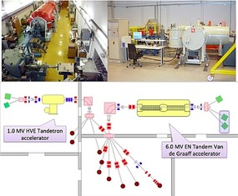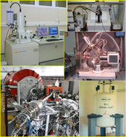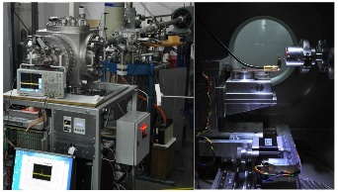
~ 18:00 | Welcome Reception (sponsored by RCDL)
Tuesday, 05th June – Hall 1
SESSION 2B: IRRADIATON EFFECTS ON COMPONENTS OF THE CH OBJECTS
9:00 – 9:40 | Introduction lecture 2: Maja Šegvić Klarić – CROATIA  Gamma-irradiation for cultural heritage – could it prevent fungal growth on paper materials?
9:40 – 10:00 | Irina Pucić–CROATIA  Radiation effects on some of the materials constituting CH objects - recent research of the RCDL scientists
10:00 – 10:20 | Enrique Francisco PRIETO MIRANDA – CUBA  (TBD)
10:20 – 10:40 | Oleksandr Buhay – UKRAINE  Application of nuclear techniques for cultural heritage in Ukraine: Problems and perspectives
10:40 – 11:00 | Coffee break
SESSION 3: SIDE- AND POST-IRRADIATION EFFECTS STUDIES
11:00 – 11:40 | Introduction lecture 3:  Stefania Baccaro - ITALY  Characterization of radiation processing effects in Cultural Heritage applications
11:40 – 12:00 | Petya Kovacheva - BULGARIA  Some side-effects of gamma-irradiation disinfestation on highly contaminated leathers and librarian materials
12:00 – 12:20 | Kumarawadu Ruwan Chandima De Silva - SRI LANKA  Application of Radiation Surface Modification Techniques for the Preservation of Achieved Materials in Sri Lanka
12:20 – 13:30 | Lunch
13:30 – 15:00 | Introduction on the working group discussions and  formation of the working groups
 | Working group on the Recommendations for safe CH components irradiation | Working group on the Uniform irradiation Procedures | Working group on the  Analytical tools for safe irradiation of CH
15:00 – 15:30 | Coffee break
17:00 – 18:30 | Guided tour of the city center

Wednesday, 06th June – Hall 1

SESSION 4A: CURRENT PRACTICES IN RADIATION CONSERVATION OF CH OBJECTS
9:30 – 10:10 | Introduction lecture 4: Celina Horak - ARGENTINA  Radiation processing and nuclear techniques capabilities related to cultural heritage in Argentina
10:10 – 10:30 | Hassan Abd El-Rehim - EGYPT  Use of Radiation Technology for Preservation of Some Egyptian Cultural Heritage Artifacts
10:30 – 10:50 | Hae-Jun Park – KOREA  Application of irradiation technology for conservation of cultural heritage in Korea: Control of fungi and insect in wood cultural heritages
10:50 – 11:20 | Coffee break
SESSION 4B: CURRENT PRACTICES IN RADIATION CONSERVATION OF CH OBJECTS
11:20 – 11:40 | Dagmara Chmielewska-Śmietanko - POLAND  Electron Beam for Preservation of Biodeteriorated Cultural Heritage Paper-Based Objects
11:40 – 12:00 | Arbi Mejri - TUNISIA  Developing of Radiation Treatment Methodologies for Preservation of Tunisian Cultural Heritage: Application in the preservation of women's ceremonial dress in noble textile
12:00 – 13:00 | Lunch
13:00 | Visit to chapels in the Sisak region  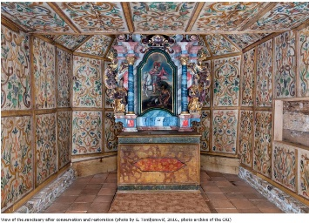
 | Conference Dinner (sponsored by IAEA)
Thursday, 07th June
SESSION 5: PROCEDURES FOR IRRADIATION OF CH OBJECTS (incl. dose mapping, dose limit ratio, simulation techniques)
9:00 – 9:40 | Introduction lecture 5: Constantin Daniel Negut - ROMANIA  Disinfestation of artefacts by gamma irradiation in Romania
9:40 – 10:00 | Volodymyr Morgunov – UKRAINE  Numerical Simulation of the Radiation Treatment of Cultural Heritage by Bremsstrahlung X-Rays
10:00 – 10:20 | Coffee break
SESSION 6: CONSOLIDATION: New radiation curable resins
10:20 – 11:00 | Introduction lecture 6: Laurent Cortella - FRANCE  Uses and Prospects in Gamma Biocide Treatments and Radiocurable Resin-Based Consolidation Treatments for Cultural Heritage Artefacts
11:00 – 11:20 | Luis M. Ferreira - PORTUGAL  Hybrid materials (gel/solid) by ionizing radiation for conservation of non-metallic inorganic historical materials
11:20 – 11:40 | Maria Helena Casimiro - PORTUGAL  Gels for cleaning artworks
11:40 – 12:00 | Alexandra Rodrigues - PORTUGAL  A case study of consolidation in Conimbriga: The House of Trident and Sword
12:00 – 13:00 | Lunch
13:00 – 14:30 | Working group discussions
 | Working group on the Recommendations for safe CH components irradiation | Working group on the Uniform irradiation procedures | Working group on the  Analytical tools for safe irradiation of CH
14:30 – 15:00 | Coffee break
15:00 – 16:30 | Presentations of the discussions and outcomes of the Working groups
18:00 – 19:00 | Guided tour of the Cathedral and Treasury  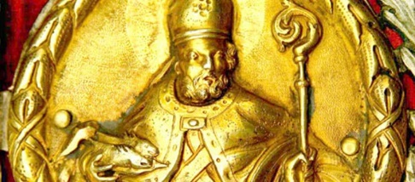
~ 19:30 | Joint Dinner (Optional at the participants’ expense)
Friday, 08th June
9:00 – 10:30 | Drafting the meeting report
10:30 – 11:00 | Coffee break
11:00 – 12:00 | Formulation of Action Plan and Recommendations  Finalization and approval of the meeting report
12:00 – 12:30 | Conclusions and closing remarks

Visit to the RBI Laboratories:

- Radiocarbon Laboratory
- Laboratory for Ion Beam Interactions (LIBI, Accelerator)
- Radiation Chemistry and Dosimetry Laboratory (RCDL):
visit to gamma irradiation facility used for radiation treatment of cultural artifacts

