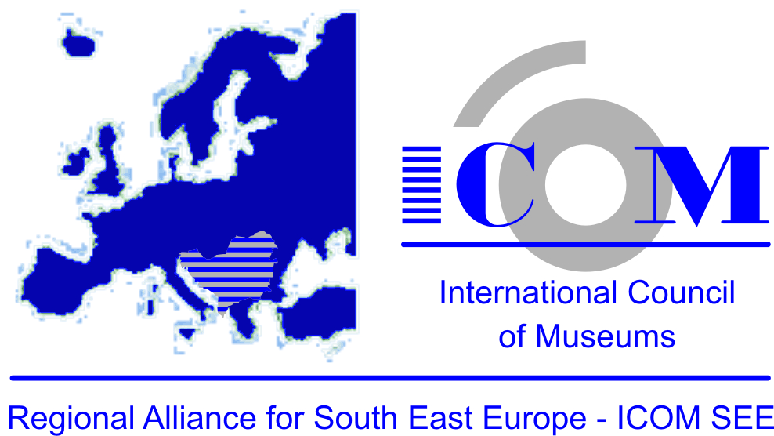

III REGIONAL SCIENTIFIC CONFERENCE
The main strategic themes
"REVITALIZATION OF CULTURAL AND NATURAL HERITAGE IN THE REGION OF SOUTH EAST EUROPE" 2006-2016.
8-11 December 2016. Alfa BK University in Belgrade

The theme of the conference:

"The results of the revitalization of cultural and natural heritage in the region of Southeast Europe in the period 2006-2016"

The Conference organizers: RA ICOM SEE, Alfa BK University, Karić Foundation
The Conference cooorganizers: National Committee ICOM Albania, National Committee ICOM Bosnia and Herzegovina , National Committee ICOM Bulgaria, National Committee ICOM Montenegro, National Committee ICOM Croatia, National Committee ICOM Macedonia, National Committee ICOM Moldova, National Committee ICOM Romania, National Committee ICOM Slovenia, National Committee ICOM Serbia
Partnership participants: Professional national, regional and international institutions, associations and organizations in the field of heritage (museums, institutes for protection of cultural monuments, Institute for Protection of Cultural Monuments, archives, libraries, centers and institutes for research, conservation and documentation of heritage, Universities and colleges in the field of heritage protection, Travel agencies, Urban services and authorities, Professional security services, Local government, National authorities are bound to heritage and others.

Conference topics: Results revitalization of heritage in the region of Southeast Europe. Setting priorities and programs of remediation or risk management program with the cultural and natural heritage in South East Europe for the following: Architectural and monumental heritage, Industrial heritage, Archaeological heritage-sites, Material heritage (museum objects, archival, library and film material), Intangible heritage, Natural heritage, Management of heritage.

Place and date : 8 - 11 december 2016.
Alfa BK University in Belgrade, Palmira Toljatija 3, 11070 Novi Beograd, Serbia
IMPORTANT DATES:
July 30, 2016: The deadline for submitting applications for participation in the theme or the posters
July 30, 2016: The deadline for abstract and concise professional CV
Instructions for preparing abstracts:
Fund: 350 words, the full name of the scientific, academic and professional titles, institution; to 6 keywords, 1-2 photos.
Font: Times New Roman 11
With abstracts send and concise professional CV to a maximum of 2 pages of text
Abstract and CV sent to their native language and english
September 10, 2016: Notification to authors on acceptance of abstracts and posters
November 8, 2016: The deadline for applications for participation in the Conference
December 1, 2016: Printing Paper Abstract

The participation fee for the III Regional Scientific Conference : 50 €
Price for the commercial representation: Depending on the size of the stand space for exhibition and billboards to posters and informational materials, 100 € / m².
For non-commercial institutions (museums, institutions of protection heritage and other professional organizations) price for the lease of stands and billboards is 40 € / m².

The Organizing Committee of the Conference:
President: Prof. PhD Mila Popović-Živančević (Serbia)
Members: M.Sc Branislava Mihajlova (Macedonia), Zaharinka Aleksoska-Bačeva ( Macedonia), PhD Sarita Vujković (Bosnia and Herzegovina), Alma Leka (Bosnia and Herzegovina), Davor Furlanović (Croatia), Vlatka Filipčić-Maligec (Croatia), Nina Zdravić - Polić (Slovenia), Ljiljana Zeković (Montenegro), Zdravka Mihajlova Bugarska, Petar Delčev (Bugarska), Sabina Veseli (Albania), PhD Virgil Stefan Nitulesku (Romania).

Operational Secretary: MA Aleksandar Joksimović, Serbia

Program Council:
President: Goranka Horjan, (Croatia)
Members: PhD Ilirian Gjipali (Albania), PhD Sarita Vujković and Alma Leka, (Bosnia and Herzegovina),PhD Darko Babić (Croatia), Petar Delčev (Bulgaria), Zaharinka Aleksoska- Bačeva (Macedonia), Ljiljana Zeković and MA Mileva Pejaković Vujošević (Montenegro), PhD Dan Octavian Paul (Romania), Slavoljub Pušica ( Serbia), Carolina (Nina) Zdravič-Polič – (Slovenia), M.Sc Slavko Spasić (Serbia).

The Scientific Committee of the Conference
President: Academician, Prof. Jan Kišgeci, PhD, (Serbia)
Members: Docent Ilirian Gjipali (Albania), PhD Sarita Vujković and PhD Milica Kotur – (Bosnia and Herzegovina), Prof. PhD Davorin Trpevski (Macedonia) , PhD Darko Babić – (Croatia); Prof. Donatella Cavezzali (Italy), PhD Sergiu Pana (Moldova), PhD Paul Octavian, (Romania), PhD Gabriela Petkova-Campbell ( Bulgaria), PhD Tanja Roženbergar (Sloveija), PhD Marietta Mikluš (Slovenia), Prof.PhD Mila Popović-Živančević (Serbia); Prof.PhD Violeta Šiljak (Serbia).

The reviewers of the Book abstract
PhD Krste Bogoeski (Macedonia), PhD Milica Kotur ( Bosnia and Herzegovina), Prof. PhD Violeta Šiljak (Serbia), PhD Virgil Stefan Nitulesku (Romania), PhD Elizabeth Jani (Italy), PhD Marietta Mikluš (Slovenia).
Presentation: 15-20 minutes

Program and content of the Conference: Preliminary draft program and content of the Conference,
Results revitalization of cultural and natural heritage in the SEE region in the period from 2006 to 2016.
"Setting priorities and programs of rehabilitation",
"Risk management at cultural and natural heritage in the Balkan region"
Science and heritage
Scientific research and heritage
Results revitalization in the field of scientific research; The development of new theories and methodologies of protection and conservation of heritage; The results of the application of new technologies, techniques and methodologies for research and evaluation of heritage, conservation and preservation, presentation of heritage; The development of new technologies and materials for the improvement of the environment, improvement of risk management and prevention of cultural heritage and natural environment.
Education and Heritage
Education and training
The results achieved in the field of education and development of primary, secondary and higher education; Heritage and educational practices; The results of improving the quality, equity and efficiency of education.

Heritage and Society
Legislation and heritage
The results achieved in the field of legislation: The laws on the protection of cultural heritage, the laws on scientific work, education laws, laws on urban planning; laws on the protection of nature; The laws on local government, tourism, labor relations and other laws that are related to the inheritance.
Heritage and social perception
The results achieved revitalization of heritage and answer to modern society (local, the district, national and regional level); Politics of Culture and professional culture heritage institutions;
Professional and social ethics in the field of heritage; Heritage and Diaspora.
Management of heritage
The results of revitalization in the development of management in the protection of heritage, The role of local and national communities in the management of heritage; The development of the concept of sustainable development; Sustainable development in the field of research, conservation and presentation of cultural and natural heritage; Development of joint management of natural and cultural heritage; Marketing of cultural heritage and creating the environment; cultural, rural, religious, pilgrimage tourism, eco, geo -tourism; project management.
Protecting heritage
Protection of cultural heritage
Results revitalization in the field of architectural and monumental heritage; Results revitalization in the field of industrial heritage; Results revitalization at archaeological sites and archaeological heritage; Results revitalization with the museum, archive, library materials; The results of revitalization for the preservation of intangible heritage; Results revitalization in the development of memorial museums, legacies, foundations.
Protecting the natural heritage
Development of a common concept for the protection of cultural heritage, natural environment and natural heritage; The achievements of science conservation of natural heritage; The results of the protection of bio-cultural diversity; Results protect natural resources and environment; The results of the protection of rare species of wild and domestic animals, rare and indigenous species of plants; The results of the protection of natural sites, natural rarities and specificity, remarkably specimens cultural landscape; Sustainable development of environmental ecology.
Documentation of heritage
The results of system development documentation for cultural and natural heritage; The application of new techniques and technologies in the documentation of heritage;
Development of advanced methods and data processing systems.
Security heritage
Results in the field of system security heritage;
Emergency Situations
Fire, floods, storms and strong winds, earthquakes, terrorism, vandalism, war circumstances.
Iilegal actions
Illegal trafficking, robbery object inheritance, forgery, illegal construction, illegal archaeological excavations.
Improper professional intervention on heritage
Inappropriate conservation interventions; Inadequate valorization of heritage; Inadequate presentation, promotion and inclusion of heritage in modern life, and others.

Parallel activities
Poster Session, Section for presentations, Fair (publications, copies, replicas, informational and promotional materials, professional equipment and materials, etc.).
Round tables and workshops during the conference
Workshop "Methods of preservation and protection of intangible heritage '
Workshop - Application of new technologies in research, conservation, documentation, presentation, promotion of heritage.

Excursion program
The duration of the working part of the Conference:
Tour of cultural and historical monuments, museums, galleries, archaeological site in Belgrade.
Excursion after the conference, the third day of the Conference:
Manastir Krušedol, Sremski Karlovci, Novi Sad and Kulpin.

The language to be used at the Conference: native language and english

Proceedings of the III Regional Scientific Conference is being prepared during 2017.
The deadline for sending texts, with an English translationis, is April 31,2017.
The language to be used for Proceedings of the III Regional Scientific Conference is native language and English.
Responsible for correspondence and notices

Aleksandar Joksimovic, contributor, ALFA BK University
+ 381 11 26 99 039/214, + 381 63 88 47847
Email: rsc.icomsee@alfa.edu.rs
Iva Ljesar, asistent, ALFA BK University,
+ 381 11 26 99 039/214, + 381 65 22 53 252
Email: rsc.icomsee@alfa.edu.rs @alfa.edu.rs
Maja Bjeletić, poslovni sekretar, ALFA BK University,
+ 381 11 26 99 039, + 381 64 54 88 515
Email: rsc.icomsee@alfa.edu.rs

