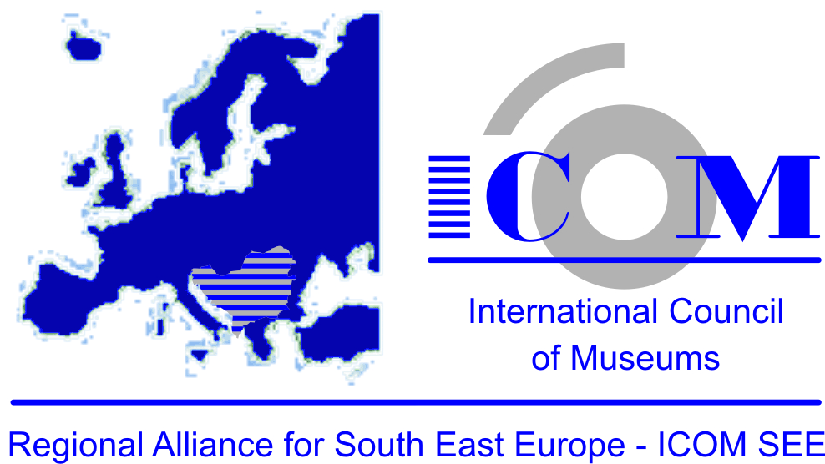
ANNEX 3
APPLICATION
FOR III REGIONAL SCIENTIFIC CONFERENCE
"The results of revitalization of the cultural and natural heritage in the region of Southeast Europe in the period from 2006 to 2016"

Name and surname
Scientific / Academic / Professional title and references
Zanimanje
Work place currently
Institution where you are employed
Address
City
Country
Phone, mobile
Fax
Email
The address to which you want to be notified (institutional, private, email)
I want to participate in the conference
I intend to present the work to the following theme: “
I intend to present my poster with the following: "
The date of registration for participation in the Conference
Rok I login if only you participate in conference | November 8, 2016.

