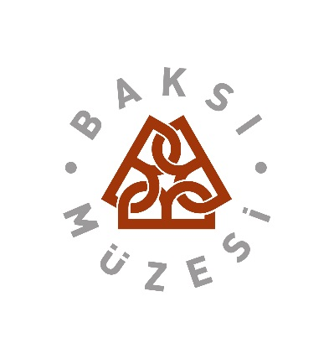

WORKSHOP
REGIONAL MUSEUMS AS GENERATORS OF DEVELOPMENT

Organising partners:
ICOM Europe
ICR - International Committee for Regional Museums
ICOM South East Europe Regional Alliance
ICOM Turkey, ICOM Azerbaijan, ICOM Greece, ICOM Croatia
European Museum Forum
Baksi Museum

Under the auspices of the Council of Europe

İntroductıon
The workshop will interactively explore the importance of seeing the museum as a unique valuable asset for development. The sessions will focus on the following subthemes:
1. Connections museums may establish between living culture and the region
2. Museum context, tangible, and intangible cultural assets
3. Transformation of the local potential to production
4. Museums, production and employment
The lectures and presentations are expected to offer conclusions that will be published and presented at the ICOM General Conference in Milan 2016. The conclusions will try to map quality indicators that will show decision makers the indirect and direct impact of the museum in the community. In line with the museum's mission, vision and core values those benefit indicators that can help museums prove their relevance to authorities at the same time stressing the intrinsic values of museums and their insitutional contribution – from educational to social.
The workshop aim is to present “museum success stories” and encourage positive spirit and value of museums in new social circumstances.
IMPORTANT:
Workshop proceeding are to be published by the end of October 2015 with the texts of presenters
All presenters should submit their texts ahead of the conference.

Programme
July 23 Thursday: Arrival to Trabzon (organised transport by bus to Baksi in the afternoon)
Optional: visit to Sumela Monastry and arrival to Baksı in the afternoon
Opening of the CRAFTATTRACT poster exhibition and welcome dinner in the
evening at Baksi museum

July 24 Friday: Workshop Day 1
9.00 Opening of the workshop
Addresses by the hosts and ICOM Turkey, Ministry of Culture and /or town representatives
Address on behalf of the ICOM Europe and partners – Damodar Frlan
Address on behalf of the EMF - Jette Sandhal, EMF Judge, Denmark
Adress on behalf of Baksı Museum
Keynotes on museum context, tangible, and intangible cultural assets
Representative of the MuCEM, Council of Europe Museum Prize Winner 2015
Workshop topics presented by workshop leaders in sessions to follow:

- Museums, production and employment
Goranka Horjan, Benefit indicators for the Community
Jose Gameiro: Title to define
Vesna Marjanović: Decision-maker’s perspective
Dicussion and conclusions
- Museums and national and international markets
Luis Raposo ICOM Europe Lisbon Declaration
Rune Holbek, ICR Chair
Orit Sahmir, ICR Treasurer
Dicussion and conclusions
Coffee break
- Transformation of the local potential to production
Husamettin Kocan: Good practice example from the Baksi Museum
Suay Aksoy, Chair ICOM Advisory,
Dicussion and conclusions
Teti HADJINICOLAOU, ICOM Greece
Roya Taghieva, ICOM Azerbaijan,
Darko Babić, ICOM Croatia
Mila Popović Živančević, ICOM SEE

July 25 Saturday: Workshop Day 2
Field work is scheduled for the morning focusing on the subtopic: Sustainability of the local culture and involvement into life by renewal
Visits to local weaving workshops
Lunch
Roundtables to discuss the workshop outcomes
Plenary session where representatives from each roundtable will present their report that might eventually contribute to the making of a model proposal for a regional eco-museum.

Evening: A gala dinner or a “highland gala breakfast” will be organised to crown the event.

July 26 Sunday: Departure for the airport (by bus organised by hosts)

